[ ] Indicates material parenthetical to the worship planners, to be deleted from the worship folder
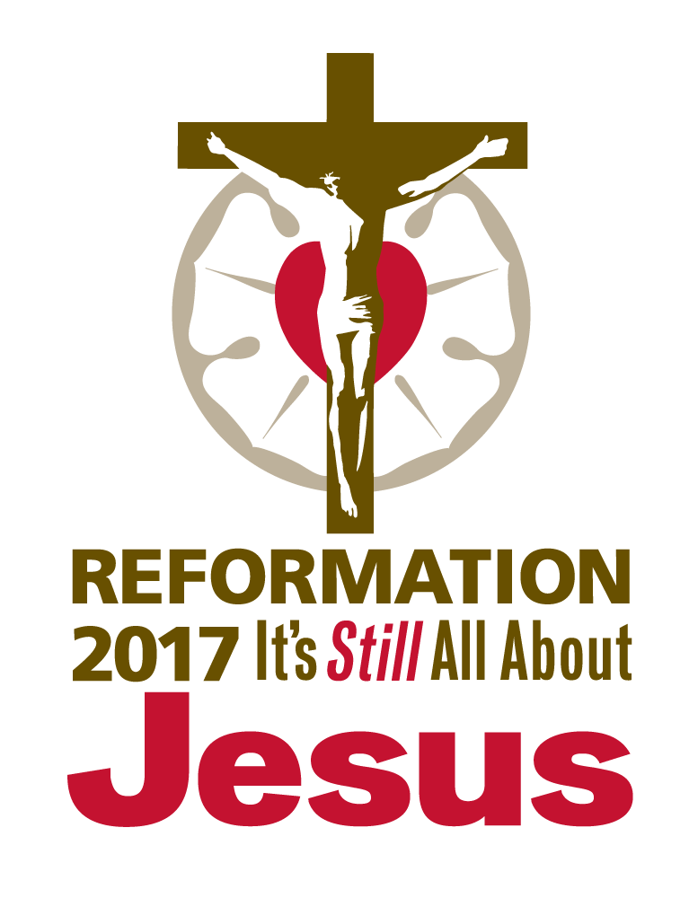
( ) Indicates instructions to the congregation, to appear in the worship folder

REFORMATION DAY

October 31, 2017
Observed: October 29, 2017

AS WE GATHER

“It’s still all about Jesus.” It was all about Jesus when the Lord God first promised a Savior to Adam, Eve, and their descendants. It was all about Jesus with every foretelling of the coming Christ by Old Testament prophets. It was all about Jesus at the manger, the cross, and the empty tomb. It was all about Jesus as the apostle Paul penned, “We hold that one is justified by faith apart from works of the law” (Romans 3:28). It was all about Jesus when Martin Luther posted his Ninety-Five Theses on October 31, 1517. It’s still all about Jesus today as we receive the Means of Grace—Word and Sacrament. It will be all about Jesus when He returns in glory on the Last Day. As we observe the 500th anniversary of the Reformation, we celebrate that it always has been, and always will be, all about Jesus!

CONFESSION AND ABSOLUTION

HYMN OF INVOCATION “By Grace I’m Saved” [LSB 566; LW 351; TLH 373]

INVOCATION

The sign of the cross may be made by all in remembrance of their Baptism.

Pastor: In the name of the Father and of the Son and of the Holy Spirit.
People: Amen.

CONFESSION AND ABSOLUTION

Pastor: If we say we have no sin, we deceive ourselves, and the truth is not in us.
People: But if we confess our sins, God, who is faithful and just, will forgive our sins and cleanse us from all unrighteousness.

Silence for reflection on God’s Word and for self-examination.

Pastor: Let us then confess our sins to God our Father.
People: Most merciful God, we confess that we are by nature sinful and unclean. We have sinned against You in thought, word, and deed, by what we have done and by what we have left undone. We have not loved You with our whole heart; we have not loved our neighbors as ourselves. We justly deserve Your present and eternal punishment. For the sake of Your Son, Jesus Christ, have mercy on us. Forgive us, renew us, and lead us, so that we may delight in Your will and walk in Your ways to the glory of Your holy name. Amen.

Pastor: Almighty God in His mercy has given His Son to die for you and for His sake forgives you all your sins. As a called and ordained servant of Christ, and by His authority, I therefore forgive you all your sins in the name of the Father and of the Son and of the Holy Spirit.
People: Amen.

[OR] Confession, Small Catechism; Romans 3:22b–24

Pastor: Confession has two parts.
People: First, that we confess our sins, and second, that we receive absolution, that is, forgiveness, from the pastor as from God Himself, not doubting, but firmly believing that by it our sins are forgiven before God in heaven.

Pastor: Let us confess our sins to God our Father.
People: Most merciful God, we confess that we are by nature sinful and unclean. We have placed other gods before You. We have failed to fear, love, and trust in You above all things. We humbly ask that for the sake of Your Son, Jesus Christ, have mercy on us, so that we may delight in Your will and walk in Your ways to the glory of Your holy name. Amen.

Pastor: For there is no distinction: for all have sinned and fall short of the glory of God, and are justified by His grace as a gift, through the redemption that is in Christ Jesus.
Almighty God in His mercy has given His Son to die for you and for His sake forgives you all your sins. As a called and ordained servant of the Word, I announce the grace of God to all of you, and in the stead and by the command of my Lord Jesus Christ I forgive you all your sins in the name of the Father and of the Son and of the Holy Spirit.
People: Amen.

SERVICE OF THE WORD

INTROIT Psalm 34:1–2, 11, 22; antiphon: Psalm 119:46

I will speak of Your testimonies before kings, | [O Lord,]*
and shall not be | put to shame.
I will bless the Lord at | all times;*
His praise shall continually be | in my mouth.
My soul makes its boast | in the Lord;*
let the humble hear | and be glad.
Come, O children, lis- | ten to me;*
I will teach you the fear | of the Lord.
The Lord redeems the life of His | servants;*
none of those who take refuge in Him will | be condemned.
Glory be to the Father and | to the Son*
and to the Holy | Spirit;
as it was in the be- | ginning,*
is now, and will be forever. | Amen.
I will speak of Your testimonies before kings, | [O Lord,]*
and shall not be | put to shame.

KYRIE (p. ___ in hymnal)

HYMN OF PRAISE (p. ___ in hymnal)

SALUTATION

Pastor: The Lord be with you.
People: And also with you.

COLLECT OF THE DAY

Pastor: Let us pray.
Almighty and gracious Lord, pour out Your Holy Spirit on Your faithful people. Keep us steadfast in Your grace and truth, protect and deliver us in times of temptation, defend us against all enemies, and grant to Your Church Your saving peace; through Jesus Christ, Your Son, our Lord, who lives and reigns with You and the Holy Spirit, one God, now and forever.
People: Amen.

[OR]

Pastor: Let us pray.
Almighty and gracious Lord, as Your baptized people, You have called us to follow You. By Your Holy Spirit, grant that we abide in Your Word, that we may truly be Your disciples and know the truth, which sets us free; through Jesus Christ, Your Son, our Lord, who lives and reigns with You and the Holy Spirit, one God, now and forever.
People: Amen.

FIRST READING Revelation 14:6–7 (Fear God and give Him glory.)

Lector: This is the Word of the Lord.
People: Thanks be to God.

PSALM Psalm 46 [See service downloads for festival setting.]

EPISTLE Romans 3:19–28 (A man is justified by faith.)

Lector: This is the Word of the Lord.
People: Thanks be to God.

ALLELUIA and VERSE Luke 12:32 [See service downloads for festival setting.]

Alleluia. Fear not, little flock, for it is your Father’s good pleasure to give you the kingdom. Alleluia.

HOLY GOSPEL John 8:31–36 (The truth will set you free.)

Pastor: The Holy Gospel according to St. John, the eighth chapter.
People: Glory to You, O Lord.

(The Gospel is read.)

Pastor: This is the Gospel of the Lord.
People: Praise to You, O Christ.

[OR] Matthew 11:12–19 (He who has ears, let him hear.)

Pastor: The Holy Gospel according to St. Matthew, the eleventh chapter.
People: Glory to You, O Lord.

(The Gospel is read.)

Pastor: This is the Gospel of the Lord.
People: Praise to You, O Christ.

CHILDREN’S MESSAGE [See service downloads for message resources.]

HYMN OF THE DAY “A Mighty Fortress Is Our God” [LSB 656/657; LW 297/298;
TLH 262; see service
downloads for festival settings.]

SERMON [See service downloads for sermon resources.]

CREED Nicene Creed (as found in the hymnal)

[OR]

All: I believe in one God,
the Father Almighty,
maker of heaven and earth
and of all things visible and invisible.

And in one Lord Jesus Christ,
the only-begotten Son of God,
begotten of His Father before all worlds,
God of God, Light of Light,
very God of very God,
begotten, not made,
being of one substance with the Father,
by whom all things were made;
who for us men and for our salvation came down from heaven
and was incarnate by the Holy Spirit of the virgin Mary
and was made man;
and was crucified also for us under Pontius Pilate.
He suffered and was buried.
And the third day He rose again according to the Scriptures
and ascended into heaven
and sits at the right hand of the Father.
And He will come again with glory to judge both the living and the dead,
whose kingdom will have no end.

And I believe in the Holy Spirit,
the Lord and giver of life,
who proceeds from the Father and the Son,
who with the Father and the Son together is worshiped and glorified,
who spoke by the prophets.
And I believe in one holy Christian and apostolic Church,
I acknowledge one Baptism for the remission of sins,
and I look for the resurrection of the dead
and the life of the world to come. Amen.

PRAYER OF THE CHURCH

Prayer petitions may be followed by stanzas of “To God the Holy Spirit Let Us Pray” (LSB 768). The text of stanzas 2–4 was written by Martin Luther.

Pastor: Let us pray to the Lord, our refuge and strength, a very present help in trouble, beseeching Him to have mercy and hear us.
Lord God, while we travel as pilgrims here on earth, give us comfort in the knowledge that You have called us to be Your disciples through water and the Word. In the midst of difficult times, when waters roar and foam and mountains tremble, give us confidence in knowing that we have been set free by the Son, and so we are free indeed! The Lord of hosts is with us;
People: the God of Jacob is our fortress.
To God the Holy Spirit let us pray
For the true faith needed on our way
That He may defend us when life is ending
And from exile home we are wending.
Lord, have mercy!

Pastor: Lord God, as Your children, we are called to love You, our neighbor, and even our enemy. Give us willing hearts to love our neighbor as ourselves because You first loved us. The Lord of hosts is with us;
People: the God of Jacob is our fortress.
O sweetest Love, Your grace on us bestow;
Set our hearts with sacred fire aglow
That with hearts united we love each other,
Ev’ry stranger, sister, and brother.
Lord, have mercy!

Pastor: Lord God, You are greater than the one who is in the world, prowling and seeking to devour us. Deliver us from the old evil foe, knowing that he cannot harm us because he has been defeated by Your Son’s death and resurrection. Give us strength to resist Satan, and keep us firm in the faith You have given us. The Lord of hosts is with us;
People: the God of Jacob is our fortress.
Transcendent Comfort in our ev’ry need,
Help us neither scorn nor death to heed
That we may not falter nor courage fail us
When the foe shall taunt and assail us.
Lord, have mercy!

Pastor: Lord God, Your Son bought us with His lifeblood as the price. In Him, we are set free from sin, death, and the power of the devil. By Your Holy Spirit working through Your Word, preserve us in the one true faith, that we might abide in You until You bring us to the place You have prepared for us in Your house. The Lord of hosts is with us;
People: the God of Jacob is our fortress.
Shine in our hearts, O Spirit, precious light;
Teach us Jesus Christ to know aright
That we may abide in the Lord who bought us,
Till to our true home He has brought us.
Lord, have mercy!

Special petitions may be included here.

Pastor: Lord God, into Your hands we commend all for whom we pray, confident that for the sake of Jesus, You hear and answer. Lord, have mercy!
People: Amen.

OFFERING

OFFERTORY (p. ___ in hymnal)

SERVICE OF THE SACRAMENT

PREFACE

Pastor: The Lord be with you. 2 Timothy 4:22
People: And also with you.

Pastor: Lift up your hearts. [Colossians 3:1]
People: We lift them to the Lord.

Pastor: Let us give thanks to the Lord our God. [Psalm 136]
People: It is right to give Him thanks and praise.

PROPER PREFACE

Pastor: It is truly good, right, and salutary that we should at all times and in all places give thanks to You, holy Lord, almighty Father, everlasting God, through Jesus Christ, our Lord, who on this day overcame death and the grave and by His glorious resurrection opened to us the way of everlasting life. Therefore with angels and archangels and with all the company of heaven we laud and magnify Your glorious name, evermore praising You and saying:

[OR]

Pastor: It is truly good, right, and salutary that we should at all times and in all places give thanks to You, O Lord, holy Father, almighty and everlasting God, for You have proclaimed an eternal Gospel to all who dwell on earth, to every nation and tribe and language and people. For this Gospel, centered in Jesus Christ, we give You glory, and we worship You, who made heaven and earth. Therefore with angels and archangels and with all the company of heaven, we laud and magnify Your glorious name, evermore praising You and saying:

SANCTUS (p. ___ in hymnal)

PRAYER OF THANKSGIVING

Pastor: Blessed are You, Lord of heaven and earth, for You have had mercy on those whom You created and sent Your only-begotten Son into our flesh to bear our sin and be our Savior. With repentant joy we receive the salvation accomplished for us by the all-availing sacrifice of His body and His blood on the cross.
Gathered in the name and the remembrance of Jesus, we beg You, O Lord, to forgive, renew, and strengthen us with Your Word and Spirit. Grant us faithfully to eat His body and drink His blood as He bids us do in His own testament. Gather us together, we pray, from the ends of the earth to celebrate with all the faithful the marriage feast of the Lamb in His kingdom, which has no end. Graciously receive our prayers; deliver and preserve us. To You alone, O Father, be all glory, honor, and worship, with the Son and the Holy Spirit, one God, now and forever.
People: Amen.

[OR] Romans 3:24–25a

Pastor: Blessed are You, Lord of heaven and earth, for You have justified us by Your grace as a gift, through the redemption that is in Christ Jesus. You put Your Son forward as a propitiation by His blood, to be received by faith.
Gathered in the name and the remembrance of Jesus, we beg You, O Lord, to forgive, renew, and strengthen us with Your Word and Spirit. Grant us faithfully to eat His body and drink His blood as He bids us do in His own testament. Gather us together, we pray, from the ends of the earth to celebrate with all the faithful the marriage feast of the Lamb in His kingdom, which has no end. Graciously receive our prayers; deliver and preserve us. To You alone, O Father, be all glory, honor, and worship, with the Son and the Holy Spirit, one God, now and forever.
People: Amen.

THE WORDS OF OUR LORD Matthew 26:26–28; Mark 14:22–24; Luke 22:19–20; 1 Corinthians 11:23–25

Pastor: Our Lord Jesus Christ, on the night when He was betrayed, took bread, and when He had given thanks, He broke it and gave it to the disciples and said: “Take, eat; this is My body, which is given for you. This do in remembrance of Me.”
In the same way also He took the cup after supper, and when He had given thanks, He gave it to them, saying: “Drink of it, all of you; this cup is the new testament in My blood, which is shed for you for the forgiveness of sins. This do, as often as you drink it, in remembrance of Me.”

PROCLAMATION OF CHRIST

Pastor: As often as we eat this bread and drink this cup, we proclaim the Lord’s death until He comes. 1 Corinthians 11:26
People: Amen. Come, Lord Jesus. Revelation 22:20

Pastor: O Lord Jesus Christ, only Son of the Father, in giving us Your body and blood to eat and to drink, You lead us to remember and confess Your holy cross and passion, Your blessed death, Your rest in the tomb, Your resurrection from the dead, Your ascension into heaven, and Your coming for the final judgment. So remember us in Your kingdom and teach us to pray:

LORD’S PRAYER (Matthew 6:9–13)

People: Our Father who art in heaven,
hallowed be Thy name,
Thy kingdom come,
Thy will be done on earth
as it is in heaven;
give us this day our daily bread;
and forgive us our trespasses
as we forgive those
who trespass against us;
and lead us not into temptation,
but deliver us from evil.
For Thine is the kingdom
and the power and the glory
forever and ever. Amen.

PAX DOMINI

Pastor: The peace of the Lord be with you always.
People: Amen.

AGNUS DEI (p. ___ in hymnal)

DISTRIBUTION HYMNS

“Lord, Keep Us Steadfast in Your Word” [LSB 655; LW 334; TLH 261]
“Built on the Rock” [LSB 645; LW 291; TLH 467]
“Salvation unto Us Has Come” [LSB 555; LW 355; TLH 377]

POST-COMMUNION CANTICLE (p. ___ in hymnal)

POST-COMMUNION COLLECT

Pastor: We give thanks to You, almighty God, that You have refreshed us through this salutary gift, and we implore You that of Your mercy You would strengthen us through the same in faith toward You and in fervent love toward one another; through Jesus Christ, Your Son, our Lord, who lives and reigns with You and the Holy Spirit, one God, now and forever.
People: Amen.

[OR] LSB 655

Pastor: Lord, keep us steadfast in Your Word;
Curb those who by deceit or sword
Would wrest the kingdom from Your Son
And bring to naught all He has done.
Lord Jesus Christ, Your pow’r make known,
For You are Lord of lords alone;
Defend Your holy Church that we
May sing Your praise eternally.
O Comforter of priceless worth,
Send peace and unity on earth;
Support us in our final strife
And lead us out of death to life.
People: Amen.

[OR]

Pastor: Let us pray Luther’s Morning Prayer.
People: I thank You, my heavenly Father, through Jesus Christ, Your dear Son, that You have kept me this night from all harm and danger; and I pray that You would keep me this day also from sin and every evil, that all my doings and life may please You. For into Your hands I commend myself, my body and soul, and all things. Let Your holy angel be with me, that the evil foe may have no power over me. Amen.

[OR]

Pastor: Let us pray Luther’s Evening Prayer.
People: I thank You, my heavenly Father, through Jesus Christ, Your dear Son, that You have graciously kept me this day; and I pray that You would forgive me all my sins where I have done wrong, and graciously keep me this night. For into Your hands I commend myself, my body and soul, and all things. Let Your holy angel be with me, that the evil foe may have no power over me. Amen.

BENEDICTION

Pastor: The Lord bless you and keep you.
The Lord make His face shine on you and be gracious to you.
The Lord look upon you with favor and give you peace. Numbers 6:24–26
People: Amen.

HYMN “Though All Our Life Is like a Scroll” [See service downloads for music.]

Though all our life is like a scroll
Unrolled with blemished pages;
Though sin has shredded what was whole
And death is now our wages;
Yet here we stand in confidence,
With Jesus as our sole defense,
For He alone still saves us.
Though pompously we try to dress
In costumes of our making;
Though fig leaves of self-righteousness
Are futile and heartbreaking;
Yet filthy rags Christ gladly wore
So we would perish nevermore.
His grace alone still clothes us.
Though earth’s deep waters foam and roar
As surging waves are rolling;
Though all the nations rage with war
While bells of doom are tolling;
Yet God gives peaceful fortitude,
He nurtures us with Heaven’s food.
True faith alone still anchors.
Though critics cut out Scripture’s claims
And treat them with derision;
Though they conduct their hostile aims
With scalpels of suspicion;
Yet how the living, two-edged sword
Proclaims the dead and risen Lord!
God’s Word alone: still truthful.
Now sing a high doxology
To God who gives salvation.
Both here and in eternity
Let this be our vocation.
To Father, Son, and Spirit raise
A symphony of grateful praise,
For He alone is worthy.

[OR]

“Thy Strong Word” [LSB 578; LW 328]
ACKNOWLEDGMENTS
Published by Concordia Publishing House
3558 S. Jefferson Ave., St. Louis, MO 63118-3968
1-800-325-3040 • www.cph.org
Copyright © 2017 The Lutheran Church—Missouri Synod
Other than downloading this resource for personal, Bible study, classroom, or congregational use, other usage is prohibited. No part of this material may be transmitted in any form or by any means, electronic, mechanical, recording, or otherwise, without prior written permission of Concordia Publishing House.
Scripture quotations are from the ESV® Bible (The Holy Bible, English Standard Version®), copyright © 2001 by Crossway, a publishing ministry of Good News Publishers. Used by permission. All rights reserved.
“To God the Holy Spirit Let Us Pray” copyright © 1969 Concordia Publishing House. All rights reserved.
“Though All Our Life Is like a Scroll” copyright © 2016 Concordia Publishing House. All rights reserved.
Some liturgical material taken from Lutheran Service Book, Divine Service: Setting One, copyright © 2006 Concordia Publishing House. All rights reserved.
Service author Matthew Clark
“Though All Our Life Is like a Scroll” (text) Wilfred L. Karsten
“Though All Our Life Is like a Scroll” (music) Jeffrey Blersch
Psalm, Verse, and Hymn of the Day settings Matthew Machemer

